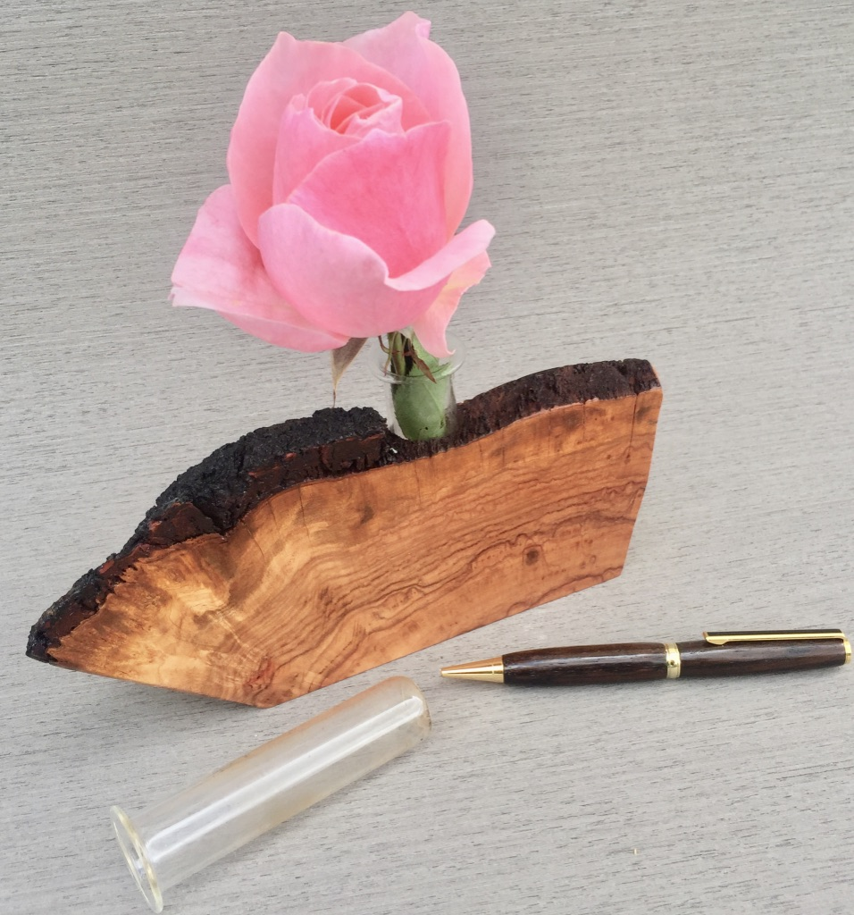
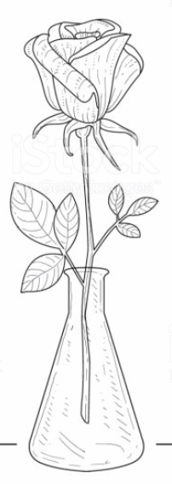
Make a Mother’s Day Gift
”Bud Vase”
From: Your Woodworking Class
Project Assignment
Worth 40 points:
Using what you have learned in our class: using wood, make a Mother’s Day Gift. A “Bud Vase” for a special person in your family: Mom, Stepmom, Grandmother, sister, neighbor, other.
Up to 20 points for each “manufacturing process” that you document (photograph) and submit to your teacher.
Some of the possible “manufacturing processes”: Locating and selecting wood, designing (drawing/sketching), dimensioning, cutting, smoothing, drilling, sanding, finishing, etc. (photograph).

You may want to use a plastic or glass tube or vial to allow water to be used for the flower of your choice. We have some suggestions to assist you in obtaining these. Extra 20 points.

You may make other “Bud Vases” for 20 points each (other gifts).

Due: “Bud Vase” project is due before Mother’s Day: Sunday May 10.
Contest: Awards for The 10 best “Bud Vases” (selected from your photograph).
Contest winners will be presented a Ten dollar ($10.) IN-N-OUT food certificate.
Judging will be done by Mr. Nic (retired woodworking teacher) and your principal.

You are encouraged to obtain assistance from others: your parents (this is not a surprise gift), grandparents, neighbors, etc.

As you are making your “Bud Vase” remember to use the safety you have learned in our class and include adult supervision.

Resources available: your teacher, and Mr. Nic: cell (626) 664-5538 for call or text (iPhone “FaceTime”), email: Nicholson.Richard@Me.com (Questions and ideas)

As you begin looking for ideas, consider: Pinterest.com, Search “Bud Vases” or “Vases”

